Cairo University Faculty of Computers and Information



**Software Engineering II**

**Software design specification document**

**2020**

**Project Team**

|  |  |  |  |
| --- | --- | --- | --- |
| **ID** | **Name** | **Email** | **Mobile** |
| 20170098 | Khaled Ezzat El-Hadary | khaledelhadary@outlook.com | 01276016539 |
| 20170093 | Hussien Ashraf Abdul-Hamid | [hussienashraf99@gmail.com](mailto:hussienashraf99@gmail.com) | 01016395068 |
| 20170085 | Hatem Mamdoh Said | matrix.leader@yahoo.com | 01016192209 |
| 20170072 | Ehap Fawzy Ibrahim | ehab1571999@yahoo.com | 01204860055 |

**T.A Mahmoud Hadad**

Contents

Class diagram design 3

Sequence diagram design 4

Github repository link 9

# 

# Class diagram design

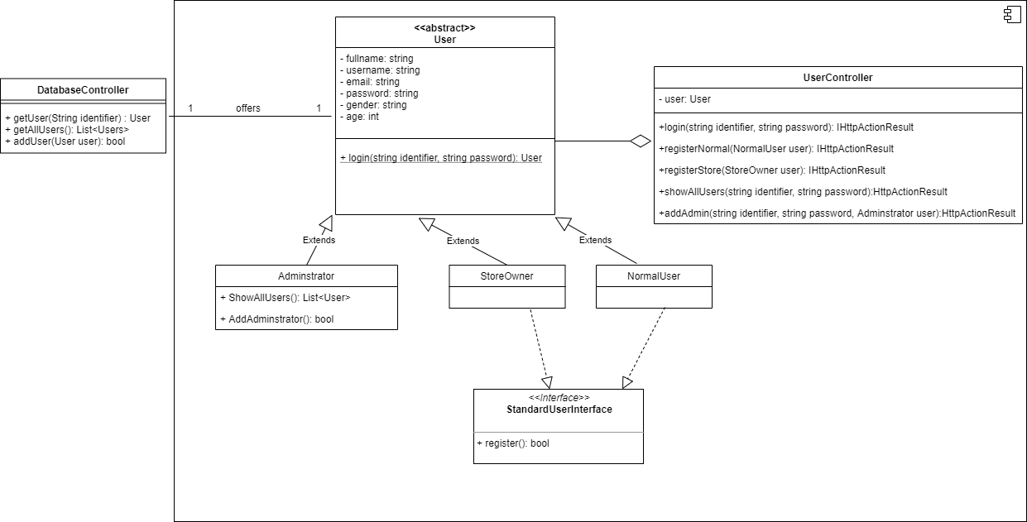

# 

# Sequence diagram design

**Register Normal User:**

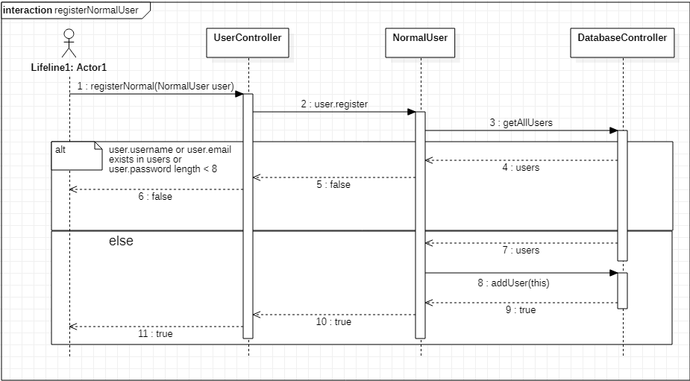

**Register Store Owner:** 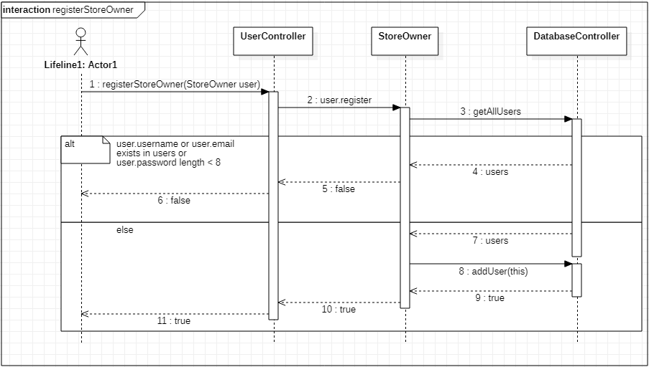

**Login:** 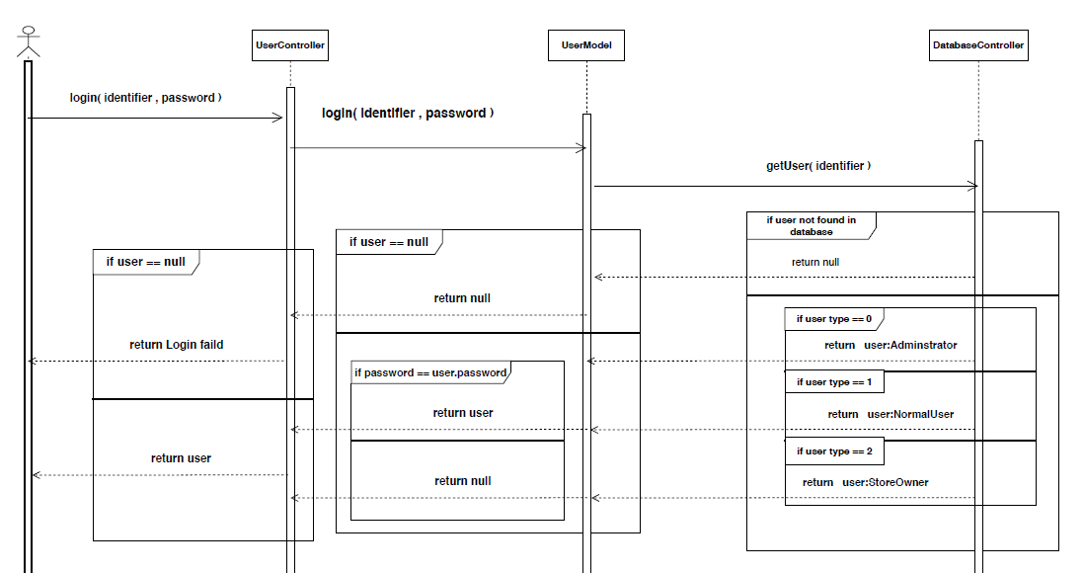

# Show All Users: C:\Users\DELL\Desktop\6th Term\SE2\ShowAllUsersSequenceDiagram.png

# Add Admin:

# 

# Github repository link

<https://github.com/FCISquad/OnlineStorePlatform>